**WS32 - SOFTWARE PRINCIPLES GROUPS**

**DATE: 03th february 2021**

**TEAM 2:**

Mateo Landazuri

Andy Calderon

Leonel Mantuano

Pablo Bustillos

Richar Maisincho

Sebastian Palacios

* Attributes in different sizes are written with camelcases

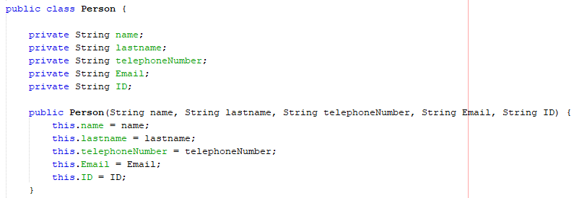

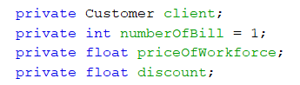

* Unnecessary comments

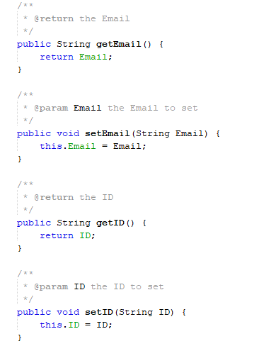

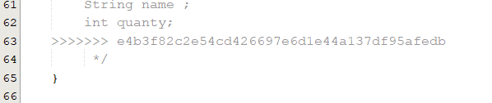

* Comments not deleted

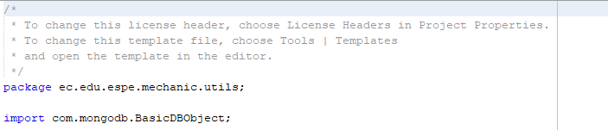

* Don’t change variable names

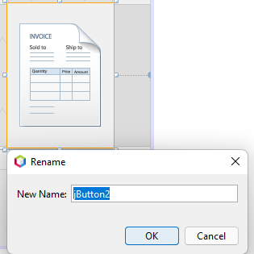

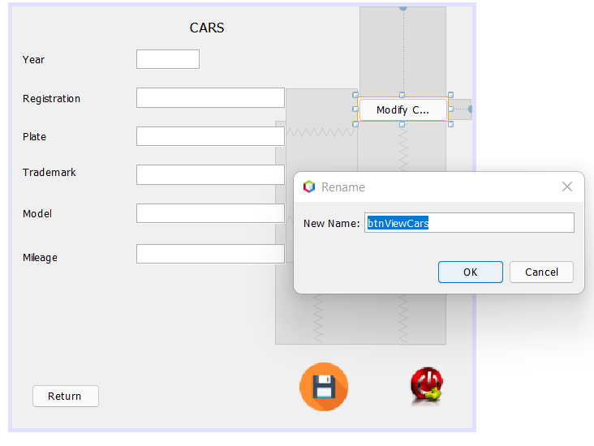

* Capital letters are not used

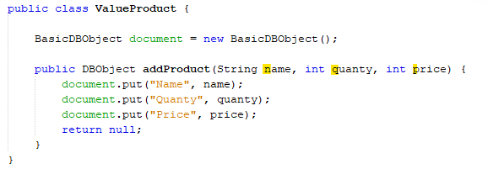

* Class names must be singular nouns

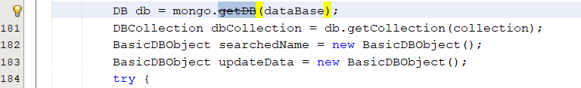

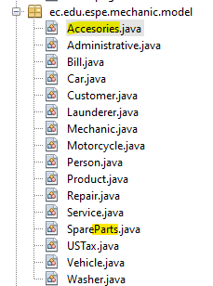

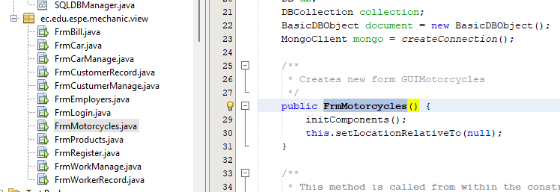

-**Single responsibility** (The connection to the database must be made by a single class, not two.)

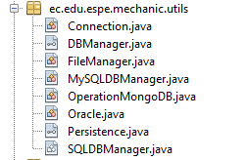

**-Open / Closed Principe**

Change the name of the array related to the project and the records it manages

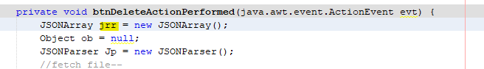

* The graphical view interface has 3 additional buttons that do not explain the operation (methods declared without using).

